Parul institute of Engineering & Technology Subject Name : Computer Networks Subject Code : 303105256



B.Tech (CSE) 4th Semester

# PRACTICAL: 8

**AIM:** Implementation of SUBNETTING.

**Subnetting Implementation in Cisco Packet Tracer**

A subnet, or subnetwork, is a part of a larger network. Subnets are a logical part of an IP network into multiple, smaller network components. The Internet Protocol (IP) is the method for transmitting data from one computer to another over the internet network. Each computer, or host, on the internet, has at least one IP address as a unique identifier.

**What is Subnetting?**

Subnetting in computer networking is essentially a method for dividing a large network into smaller, more manageable logical subnetworks. These sub-networks, also called subnets, function like independent networks within the bigger physical network.

**Steps to Configure and Verify Three Router Connections in Cisco Packet Tracer: IP Addressing Table for PCs**

**EX**:179.249.0.0

1ST NUMBERS UPP TO 249 BELONGS TO 16 BIT NET

0.0 BELONGS TO THE HOST CLASS A= 0 –1274

CLASS B= 128—190

CLASS C= 191—223

CLASS D= 224—240

CLASS E=241—255 **SUBNET MASK:**

This calculator returns a variety of information regarding Internet Protocol version 4 (IPv4) and IPv6 subnets including possible network addresses, usable host ranges, subnet mask, and IP class, among others

EX: 255.255.254.0

255=11111111 , 255=11111111 , 255=11111111 ,0=00000000-> HOST

Enrollment no : 2303031050670

Parul institute of Engineering & Technology Subject Name : Computer Networks Subject Code : 303105256

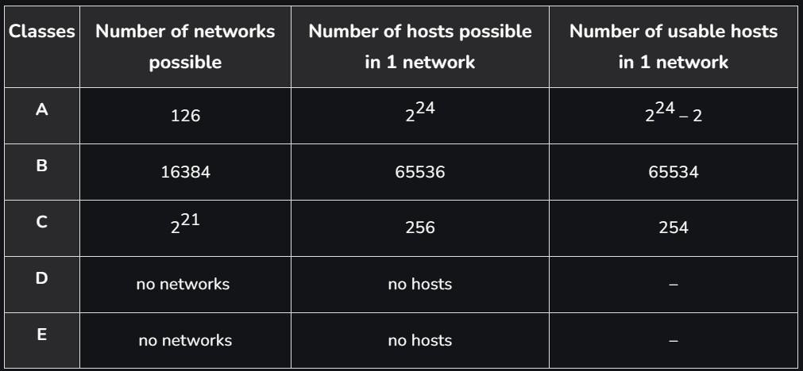

B.Tech (CSE) 4th Semester

###### 1ST AVAILABLE HOST ADDRESS:

If we speak about usable host address, the first are always 1 / 65 / 129 / 193 (network address +1) and the last one 62, 126, 190, 254 (broadcast address -1).

EX:179.249.00000000.000000001

###### LAST AVAILABLE HOST ADDRESS:

130.56.255.254 network address 130.56.255.192 first usable host address 130.56.255.193 last usable host address 130.56.255.254 broadcast address 130.56.255.255 EX:179.249.0.1

###### BROADCAST ADDRESS:

A broadcast address is a network address used to transmit to all devices connected to a multiple- access communications network. A message sent to a broadcast address may be received by all network-attached hosts**.** EX:179.244.1.255

###### MAX NO OF HOST:

RANGE**=** 2^9 -2=510

**Procedure:**

**Step 1:** Take 4 general PC’s and 2 switches and 1 Router and PC 0 and PC 1 are separate Vlan network with one switch and PC 2 and PC 3 are another separate Vlan network.

Enrollment no : 2303031050670

Parul institute of Engineering & Technology Subject Name : Computer Networks Subject Code : 303105256

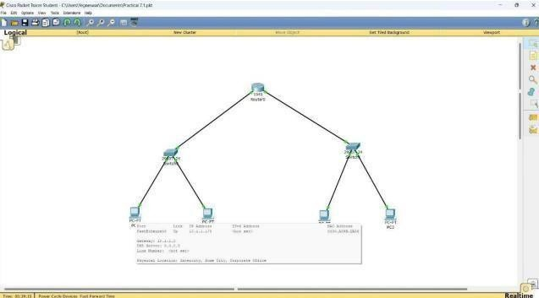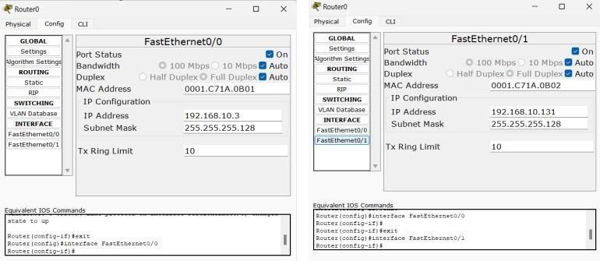

B.Tech (CSE) 4th Semester

**Step 2:** 2 pc connected to 1st switch and remaining 2 pc connected to 2nd switch with copper straight-through wire.

**Step 3:** For Router first config the two servers in by using the Fast Ethernets 0/0 and 0/1 need to give the IP address 192.168.10.3 &192.168.10.131 and Subnet mask for both is 225.255.255.128

**Step 4:** Take 2 routers and it connects with switch through copper straight wire.

**Step 5:** For 1st router config section assign ip address and subnet mask of fast ethernet0/0.and port status is also on.

Enrollment no : 2303031050670

Parul institute of Engineering & Technology Subject Name : Computer Networks Subject Code : 303105256

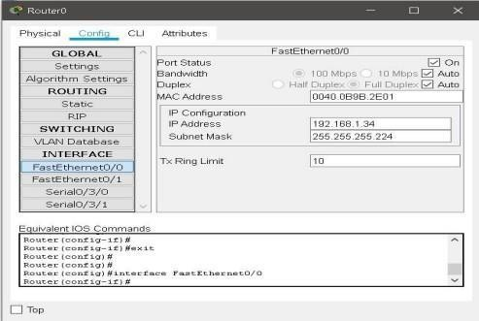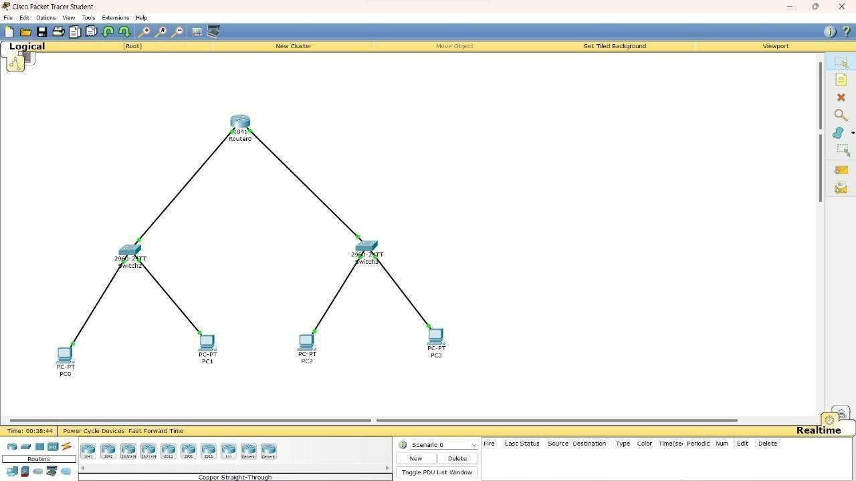

B.Tech (CSE) 4th Semester

**Step 6**: For 2nd router config section assign ip address and subnet mask of fast ethernet0/0.and port status is also on.

**Step 7**: In routers config section assign ip address and subnet mask of serial0/3/0 and serial0/3/1 and port status is also on.

Enrollment no : 2303031050670

Parul institute of Engineering & Technology Subject Name : Computer Networks Subject Code : 303105256

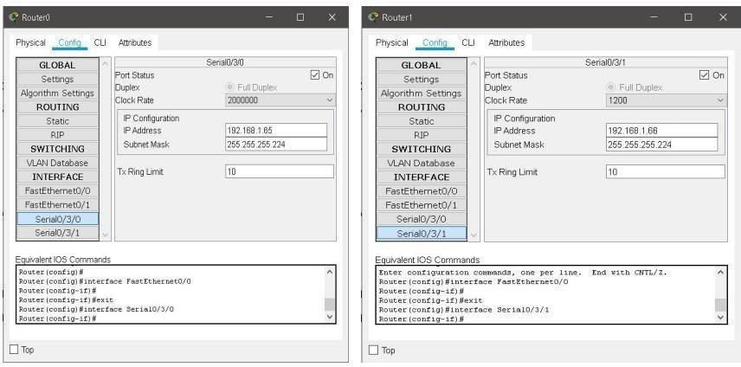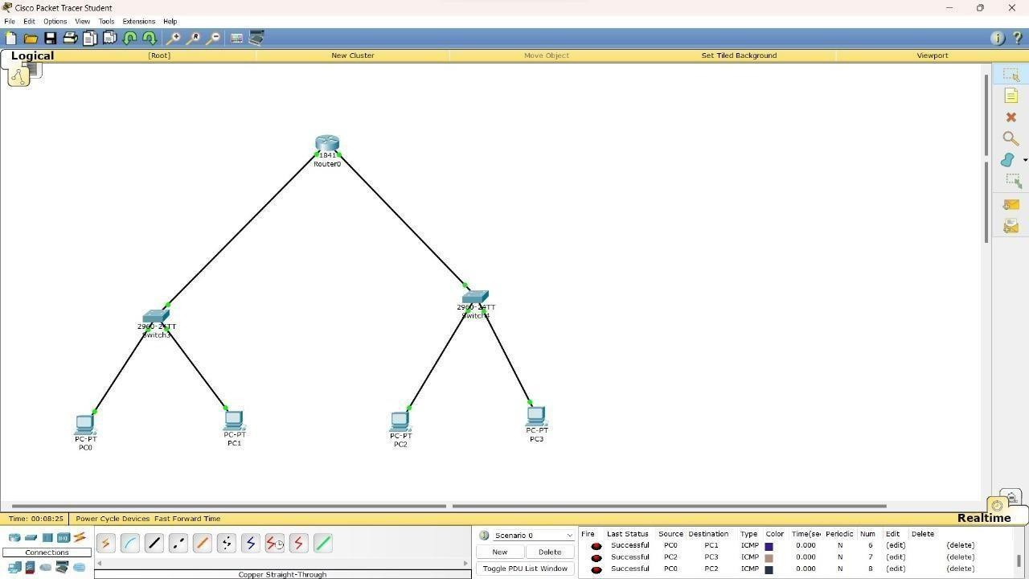

B.Tech (CSE) 4th Semester

**Step 8**: Go to static section and add the network address **Step 9**: Go to setting and save the added network address. **Step 10**: Send the packet between different subnetting.

###### OUTPUT:

Enrollment no : 2303031050670

Parul institute of Engineering & Technology Subject Name : Computer Networks Subject Code : 303105256

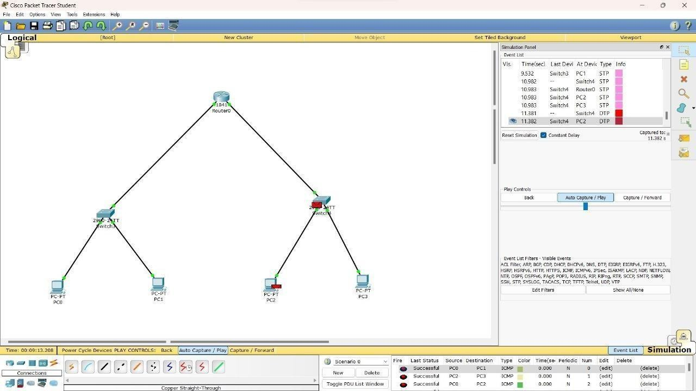

B.Tech (CSE) 4th Semester

Enrollment no : 2303031050670

## EXPERIMENT NO: 9

Parul institute of Engineering & Technology Subject Name : Computer Networks Subject Code : 303105256

B.Tech (CSE) 4th Semester

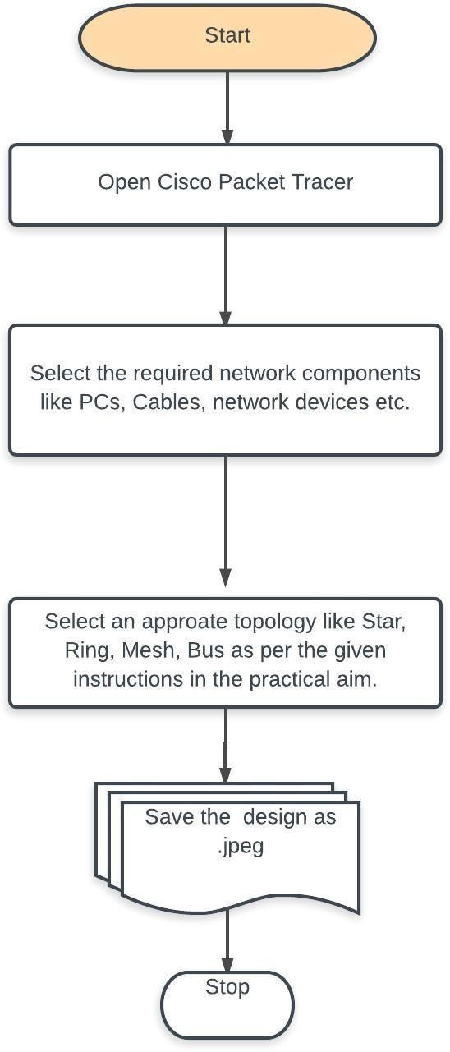

**AIM: Routing at Network Layer: Simulate Static and Dynamic Routing Protocol Configuration using CISCO Packet Tracer.**

* 1. **Purpose:**

The main objective of the proposed experiment is to implement static and dynamic routing protocol using serial and parallel routing connections. It also gives an opportunity to students to learn serial and parallel router configuration in multiple network environments.

* 1. **Logical Flow of Practical**

Enrollment no : 2303031050670

Parul institute of Engineering & Technology Subject Name : Computer Networks Subject Code : 303105256

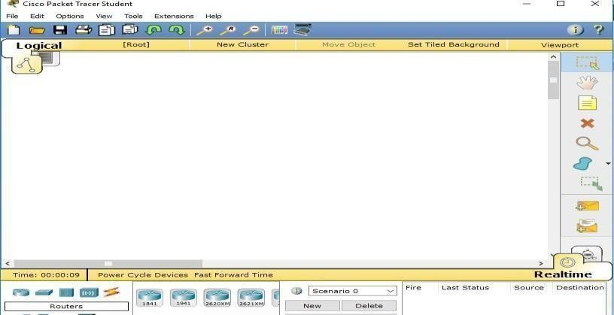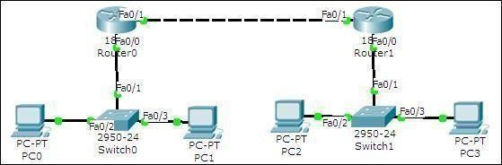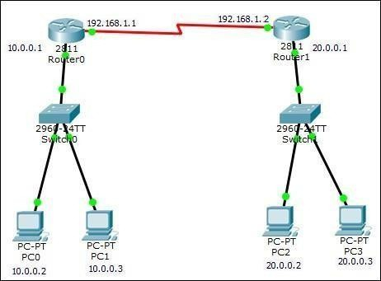

B.Tech (CSE) 4th Semester

###### TOOLS/SOFTWARE:

**Cisco packet Tracer**

* 1. **Expected Output :**

Enrollment no : 2303031050670

Parul institute of Engineering & Technology Subject Name : Computer Networks Subject Code : 303105256

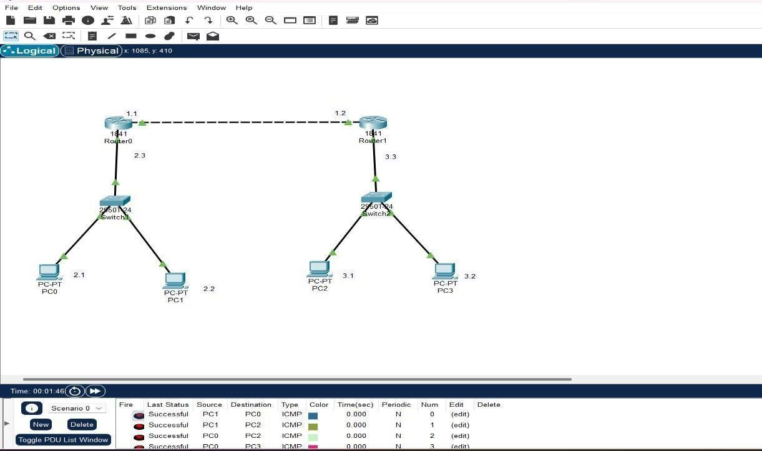

B.Tech (CSE) 4th Semester

* 1. **Practice Excercises:**

1. **Design an actual LAN network using 4 nodes. Design two subnets from the designed network using class A Ip address classes.**
2. **Design actual Wi-Fi network using 4 nodes. Design two subnets from the designed network using class A Ip address classes.**

Enrollment no : 2303031050670

Parul institute of Engineering & Technology Subject Name : Computer Networks Subject Code : 303105256

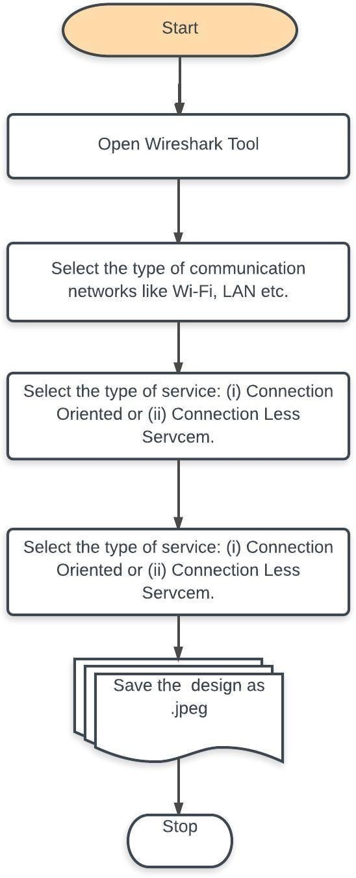

B.Tech (CSE) 4th Semester

## EXPERIMENT NO: 10

**AIM: Experiment on Transport Layer: Implement echo client server using TCP/UDP sockets.**

* 1. **Purpose:**

The main objective of the proposed experiment is to initiate communication between client and server nodes using echo client and echo server. Utilize both TCP and UDP sockets in the proposed experiment.

* 1. **Logical Flow of Practical**

Enrollment no : 2303031050670

Parul institute of Engineering & Technology Subject Name : Computer Networks Subject Code : 303105256

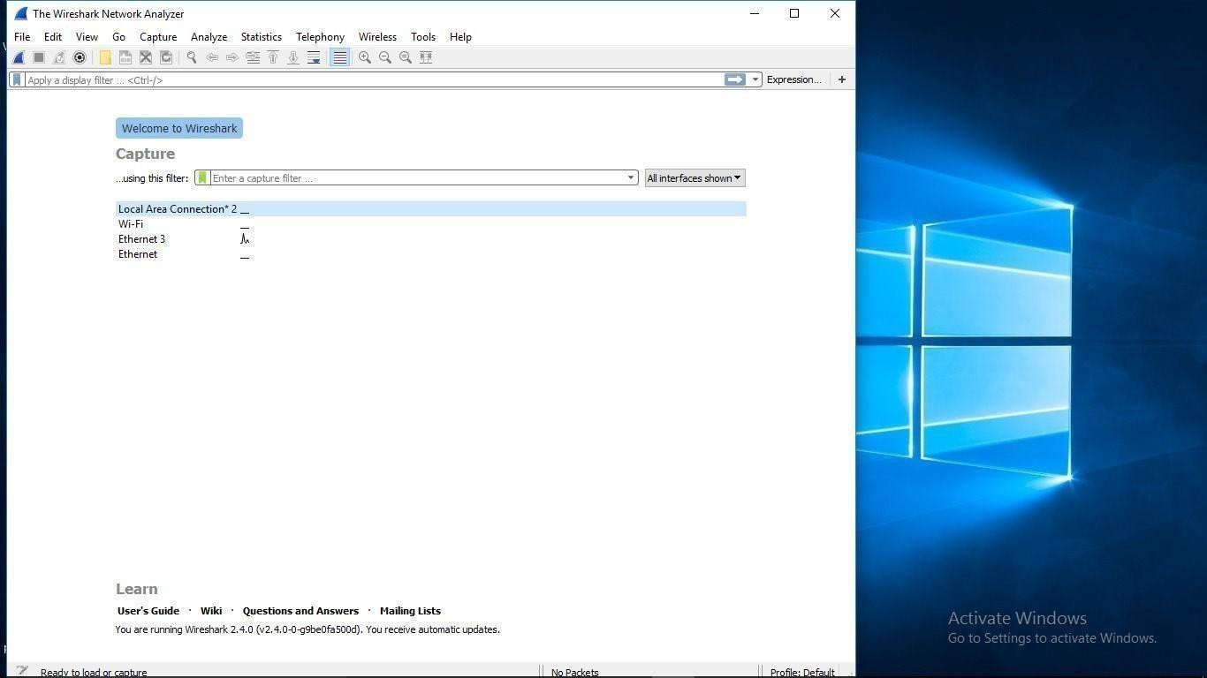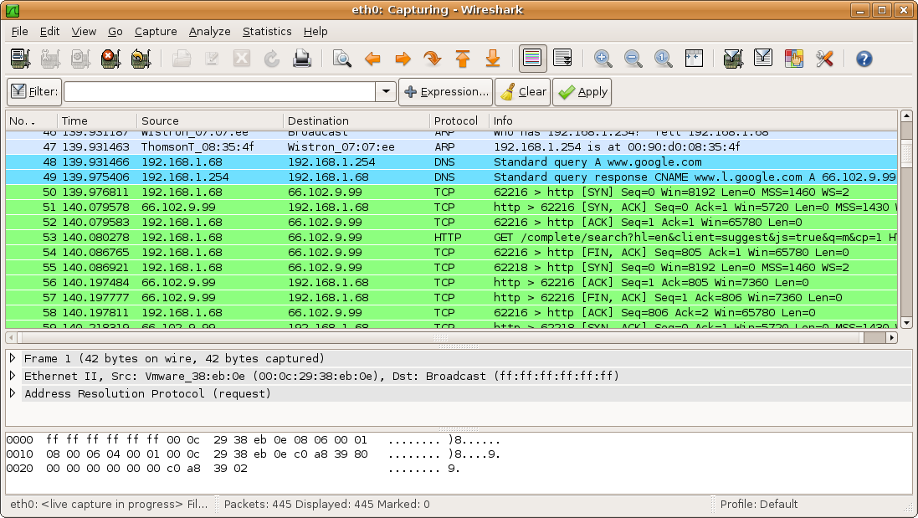

B.Tech (CSE) 4th Semester

* 1. **TOOLS/SOFTWARE: Wireshark**
  2. **Expected Output :**

Enrollment no : 2303031050670

Parul institute of Engineering & Technology Subject Name : Computer Networks Subject Code : 303105256



B.Tech (CSE) 4th Semester

* 1. **Practice Excercises:**

1. **Test asynchronous and synchronous communication using wireshark in LA environment.**
2. **Test asynchronous and synchronous communication using wireshark in Wi-Fi environment.**

#include <stdio.h> #include <stdlib.h> #include <string.h>

#include <unistd.h> #include <arpa/inet.h> int main(){

char *ip = "127.0.0.1"; int port = 5566; int sock; struct sockaddr_in addr; socklen_t addr_size;

char buffer[1024]; int n;

sock = socket(AF_INET,

SOCK_STREAM, 0); if (sock < 0){ perror("[-]Socket error"); exit(1); }

printf("[+]TCP server socket created.\n");

memset(&addr, '\0', sizeof(addr));

addr.sin_family = AF_INET; addr.sin_port = port; addr.sin_addr.s_addr = inet_addr(ip); connect(sock, (struct sockaddr*)&addr, sizeof(addr));

printf("Connected to the server.\n"); bzero(buffer, 1024); strcpy(buffer, "HELLO, THIS IS CLIENT.");

printf("Client: %s\n", buffer); send(sock, buffer, strlen(buffer), 0); bzero(buffer, 1024);

recv(sock, buffer, sizeof(buffer),

0); printf("Server: %s\n", buffer);

Enrollment no : 2303031050670

Parul institute of Engineering & Technology Subject Name : Computer Networks Subject Code : 303105256

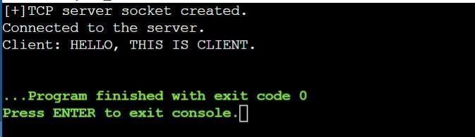

B.Tech (CSE) 4th Semester

close(sock);

printf("Disconnected from the server.\n"); return 0;

}

###### OUTPUT :

Enrollment no : 2303031050670